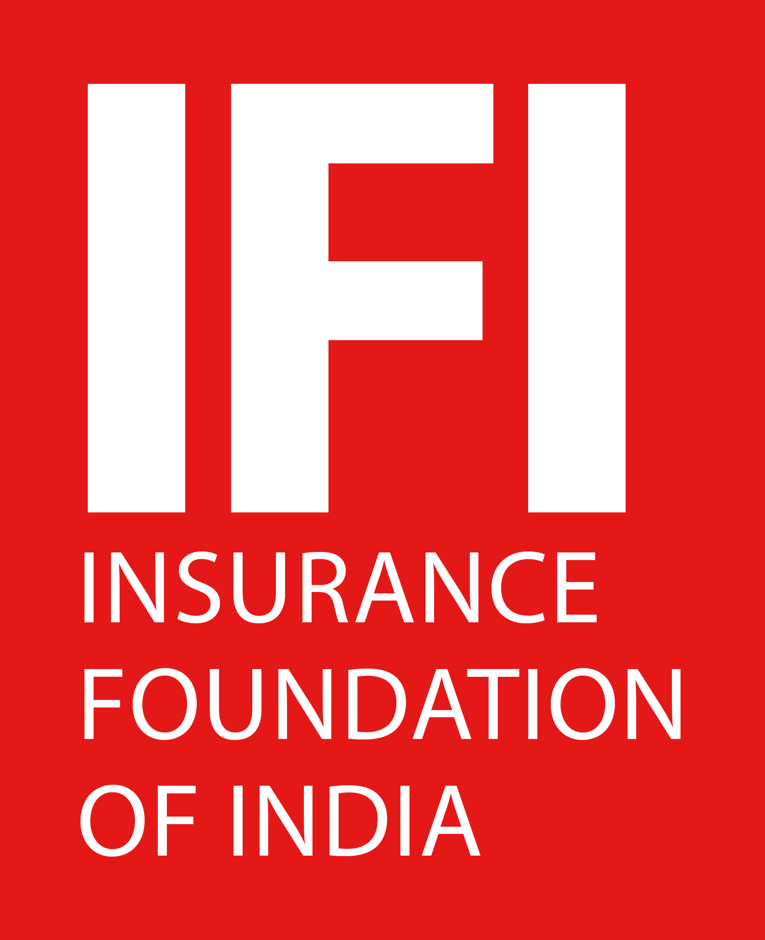------------------- RESPONSE FORM -------------------
Insurance Foundation of India
(A not for profit organization under Trust Registration Act, 1882)
Mr. Anirudh Katiyar
Programme Coordinator
Insurance Foundation of India
Om Plaza, 430/7, 1st Floor, Sant Nagar, East of Kailash, New Delhi - 110065
Mob: 7678689961/ 9015406030, Phone: 011- 46581577
Email: vp@ifingo.org Website: www.ifingo.org
Full Day Training Programme
on
“Emerging Risks & Liability Insurance”
Fri, 06 Jan 2023 Time: 09:30 AM to 05.30 PM
Venue: Muse Sarovar Portico, A-1-Chirag Enclave, Near Nehru Place,
New Delhi - 110048 (Nearest Metro station - Nehru Enclave)
Delegate Fee –
- Individual participant fee: Rs. 4500/-
- Group participation fee (team of 3 persons and above): Rs. 4250/-each
- Group participation fee (team of 5 persons and above): Rs. 4000/-each

I/ we shall participate in the above mentioned training programme. Name(s) & Designation(s) are as
S.No | Name | Designation | E-mail | Mobile
1.
2.
3.
4.
5.

Organization: _____________________________________________________________________________
Address: _________________________________________________________________________________
________________________________________________________________________________________
The Cheque/ Demand Draft No __________________ for Rs. _________________ drawn in favor of ‘Insurance Foundation of India’ payable at New Delhi is enclosed.
Please send NEFT payments to:
Beneficiary :- Insurance Foundation of India
Bank Name :- Bank of Baroda
Bank Address :- East of Kailash Branch, East of Kailash, New Delhi - 110065
Bank Account No : - 09630100010847
IFSC Code/ NEFT Code :- BARB0KAIDEL (fifth character is zero)
Swift Code :- BARBINBBNND
(SIGNATURE)

