
Mr. Rakesh Kumar, Programme Coordinator
Insurance Foundation of India
Sai Sadan, 252-K, 2nd Floor, Raja Dhirsains Marg, Sant Nagar, East of Kailash, New Delhi - 110065
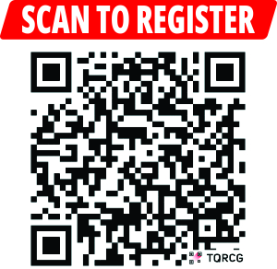Mob: 7678689961 Phone: 011- 46581577
Email: vp@ifingo.org Website: www.ifingo.org
Full Day Training Programme
on
“Marine (Cargo) Insurance”
Fri, 23 October, 2026 Time: 09:30 AM to 05:30 PM
Venue: Radico Room, PHD Chamber of Commerce and Industry
PHD House, New Delhi-110016, (Nearest Metro Station – Hauz khas)
Delegate Fee –
- Individual participant fee: Rs. 4800/-
- Group participation fee (team of 3 persons and above): Rs. 4500/-each
- Group participation fee (team of 5 persons and above): Rs. 4200/-each

I/ we shall participate in the above mentioned training programme. Name(s) & Designation(s) are as
S.No | Name | Designation | E-mail | Mobile
1.
2.
3.
4.
5.

Organization: _____________________________________________________________________________
Address: _________________________________________________________________________________
________________________________________________________________________________________
The Cheque/ Demand Draft No __________________ for Rs. _________________ drawn in favor of ‘Insurance Foundation of India’ payable at New Delhi is enclosed.
Please send NEFT payments to:
Beneficiary :- Insurance Foundation of India
Bank Name :- Bank of Baroda
Bank Address :- East of Kailash Branch, East of Kailash, New Delhi - 110065
Bank Account No : - 09630100010847
IFSC Code/ NEFT Code :- BARB0KAIDEL (fifth character is zero)
Swift Code :- BARBINBBNND (SIGNATURE)

------------------- RESPONSE FORM -------------------
Insurance Foundation of India
(A not for profit organization under Trust Registration Act, 1882)

